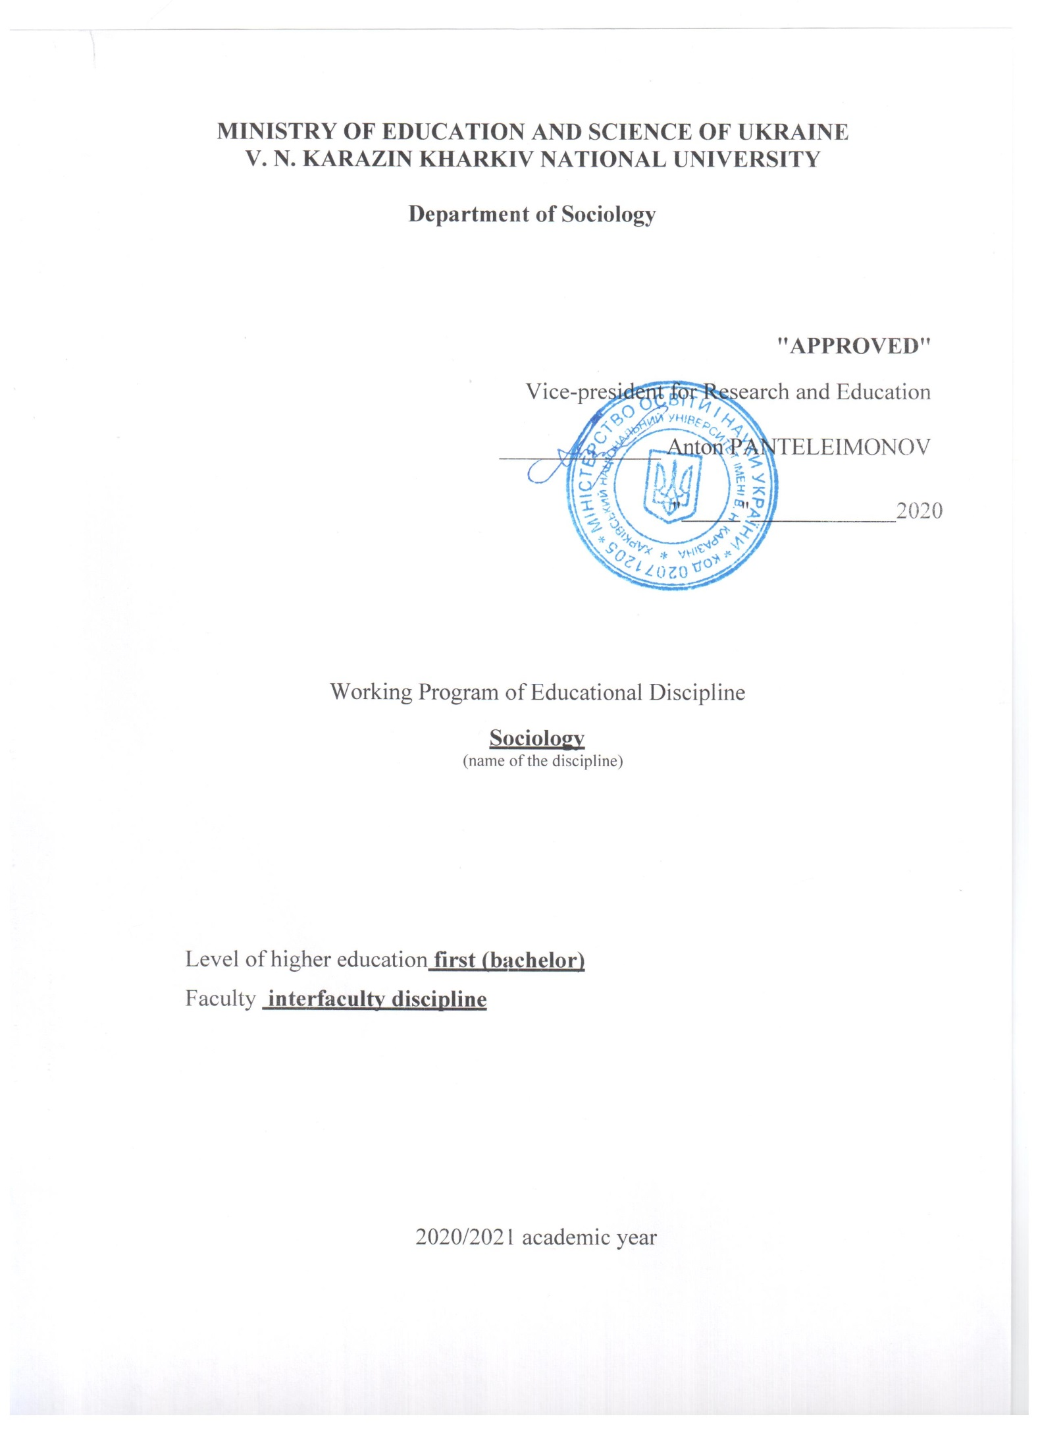
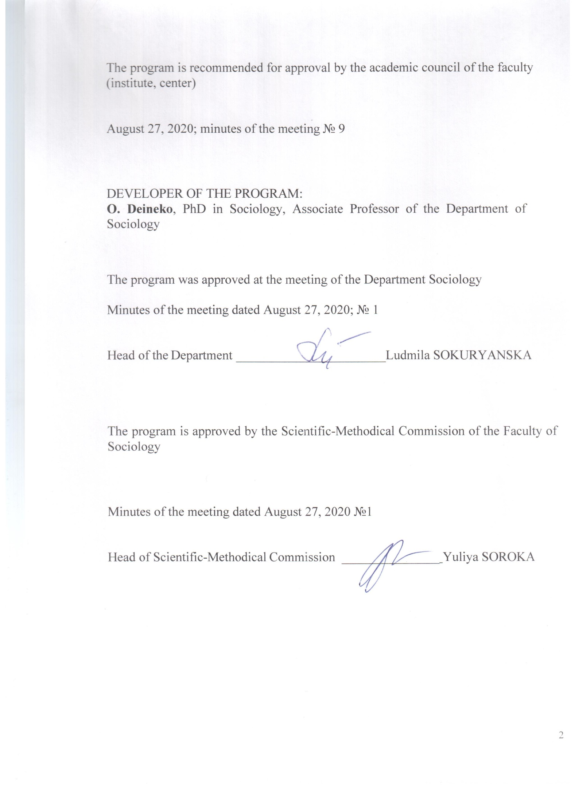

INTRODUCTION

The program of the discipline «Sociology» is compiled according to the educational-professional training program of students pursuing Bachelor’s degree.

- Description of the discipline

  - The purpose of teaching this discipline is acquainting students with features of sociology as a socio-humanitarian discipline (theoretically); formation of sociological analysis skills for studying social phenomena (practically).

  - Main tasks of the discipline:
- to disclose prerequisites for sociology emergence and its development as an independent science;
- to define the subject field of sociology, its connections with other sciences;
- to study types of sociological theories;
- to master sociology terminological apparatus, to get acquainted with the main sociological categories (personality, society, values, norms, social institutions, social practices);
- to show up peculiarities of sociological vision of social phenomena (culture, power, economics, everyday life, etc.);
- to underline features of carrying out empirical research in sociology;
- to build up students' sociological imagination.

  - Number of credits – 3
  - Total number of hours – 90

1.5. Characteristics of the discipline

By choice
Full-time study form | Part-time (distance) form of study
Year of training
2,3-th | -
Semester
3,5-th | -
Lectures (online format)
32 hours. | hours.
Practical, seminars
hours. | hours.
Laboratory classes
hours. | hours.
Self-study, included
58 hours. | hours.
Individual task
-

  - According to the requirements of the educational and scientific program, students have to acquire competencies and demonstrate the following learning outcomes:

List of subject competencies:
General:
GC01. Ability to apply knowledge in practice.
GC 04. Ability to be critical and self-critical.
GC 05. Ability to communicate with representatives of other professional groups on different levels (experts from other fields of knowledge / types of economic activity).
GC 06. Ability to act socially responsibly and consciously.
GC 08. Ability to learn and master contemporary knowledge.
GC 10. Ability to generate new ideas (creativity).
GC 11. Ability to protect their rights and responsibilities as members of society, to realize values ​​of civil (free democratic) society and need for its sustainable development, the rule of law, human and civil rights and freedoms in Ukraine.
Program learning outcomes:
PO01. Using conceptual apparatus of sociology in educational, research and other areas of professional activity.
PO02. Understanding history of sociology, its contemporary concepts and theories, its main problems.
PO04. Explaining patterns and features of development and functioning of social phenomena in the context of professional tasks.
РO08. Substantiating own position to make and argue independent conclusions based on the results of research and analysis of professional literature.

1.6. Planned learning outcomes

To know:

- basic sociological theories;
- specifics of sociological view on social phenomena;
- empirical research methods in sociology;

To be able to:

- analyze social phenomena from the standpoint of sociological analysis;
- distinguish and compare sociological theories;
- understand the results of empirical sociological research;
- be aware of the content of the main sociological categories.

- Thematic plan of the discipline

All the lectures are held online in synchronous mode using Zoom platform

TOPIC 1. Sociology as a Science of Society: What? Where? When?
Subject and object of sociology. Features of sociology. Specifics of sociological analysis of society. Historical and theoretical preconditions of emergence of sociology as science. Structure and functions of sociology. Connection of sociology with other areas of knowledge. Sociology as a multi-perspectival science. Search of a subject of sociology. Structure of sociological knowledge system. Fundamental and applied, theoretical and empirical sociology. Macro- and microsociology. Levels of sociological knowledge. Sociological imagination.

Questions for self-control:
1. What is difference between sociology and other socio-humanitarian sciences?
2. When did sociology emerge? What factors influenced this process?
3. How do you understand the statement that sociology is a multi-perspectival science? Is this statement advantage or disadvantage? Justify your answer.
4. What are levels of sociological knowledge? What is relationship between levels of sociological knowledge and subject of research?
5. What types of sociology are heuristic in studying the Ukrainians' attitude to healthy lifestyle? Justify your answer.

TOPIC 2. History of Sociology: from Ancient Times to Contemporary
Place of O. Comte's sociology in history of positivism. "Organism" of H. Spencer. Interactionism: C. Cooley, W. Thomas. Symbolic interactionism of J. G. Mead. Sociological aspects of psychoanalysis. Formal sociology: F. Tennis, G. Simmel. Marxist direction in sociology. K. Marx and F. Engels. M. Weber's understanding sociology. E. Durkheim's sociologism. Structural functionalism. Phenomenological sociology. Dramatic sociology. Social construction of reality. P. Bourdieu's constructivist structuralism. Anthony Giddens's theory of structuration. Conflict theory.

Questions for self-control:
1. What is influence of psychologism on development of sociological thought?
2. Explain the situation of teacher-student interaction in the framework of symbolic interactionism.
3. In what way understanding sociology differs from positivism? Answer the question by drawing a comparing table demostrating these approaches.
4. What useful knowledge for everyday life gives formal sociology? You’re your examples.
5. Compare the actor's acting in the theater and any of your interactions. Do they have anything in common according to the dramatic approach in sociology?
6. Why is P. Bourdieu's theory called constructivist structuralism?

TOPIC 3. Empirical Research in Sociology
Place of sociological research in the structure of sociological knowledge. Quantitative and qualitative methods in sociology. Representative surveys, focused group interviews, individual in-depth interviews, content analysis. Stages of sociological research. Sociological research program. Sample study. Methods of sociological information collecting and analyzing. Triangulation of research results. Specificities of publishing sociological research results.

Questions for self-control:
1. What are differences between qualitative and quantitative methods in sociology?
2. In what way do you understand the concept of representativeness? What are indicators of representative research?
3. What is the main task of a focused group interview method? What spheres of life is this method most often used in?
4. What is the main idea of content analysis? Which phenomena may you analyze by this method?
5. What are the main points of the sociological research program? Which components are impossible to conduct a sociological study without?
6. What are the differences between research interview, domestic and journalistic ones? Justify your answer.

TOPIC 4. Main Sociological Categories: Forming of Sociological Thinking "Framework"
Social norms and values as social integrators. Functions of social norms and values. Types of social norms and values. Sanctions and social control. Social institutions. Types of social control. The concept of social structure. Social classes and stratification approaches to social structure analysis. Deviant behavior. The concept of personality in sociology. Individual, individuality, personality. Personality types. Primary and secondary socialization, resocialization. Socialization agents. The concept of social role and status. Social groups and communities. Social mobility and its types.

Questions for self-control:
1. What role do norms and values play for society functioning?
2. What do you think to what lack of sanctions leads? How does it impact existence of norms in society? Give your examples.
3. Give some examples of social structures from your daily life corresponding certain characteristics of social structures. What do you think about usefulness of social structures knowledge for us?
4. What are correspondence terms for "personality", "individual", "actor" in various sociological theories?
5. Why do you think socialization is needed and "who" invented it? Give examples of resocialization cases you know.
6. Identify what social roles and statuses are inherent at this stage of your life. At which life period is there a maximum filling of roles and statuses? And at which one, on the contrary, reduction?
7. Could a school class be called as a social group? Justify your answer.
8. Analyzing your daily life, give examples of upward and downward social mobility you have already undergone in your life.

TOPIC 5. Sociological Study of Culture: How to "See" Symbols and Debunk Myths?
Definition of culture. Approaches to studying culture in sociology. Basic concepts of sociology of culture. Cultural relativism and ethnocentrism. Types of culture. The concept of marginality. Subculture and counterculture. High culture and popular culture. Symbols, rituals, myths, language and culture. Globalization and culture. Representative culture. Cultural form.

Questions for self-control:

1. What spheres of everyday life do you associate the concept of culture with? What definitions of this concept correspond to these ideas?
2. What are cultural universals? How do they arise? How do they continue existing? Give your examples.
3. What is the difference between the concepts of subculture and counterculture? Give your examples of each of them, basing on famous works of culture and art.
4. What rituals exist in your daily life? What role do they play? Picture your life without them.
5. What is difference between symbols and signs? What examples can you provide? What role do symbols play for society and humanity?
6. What relations exist between the concepts of language and culture? How do these concepts coexist in globalization field?
7. What cultural attributes allow you to maintain your identity in the context of globalization?
8. What is representative culture? How does this concept allow us to explain relationships between society and culture? Give your examples.
9. Provide your examples of any cultural form and describe its components.

TOPIC 6. Social Groups and Organizations: How to Be a Leader and Form Groups?
Sociology as a science of social communities. Concepts and types of groups in sociology. Primary and secondary groups. Reference groups. In-groups and out-groups. Group existence as a ground for the emergence of social phenomena of social identity, solidarity, cohesion. The difference between social groups, networks, formal organizations. Leadership and synergy in groups. Behavior strategies in a group by R. Merton. Social organizations and bureaucratic institutions. Social organizations and magdonalization of society. Sociometry.

Questions for self-control:

1. Why do you think there social groups exist? What function do they perform for society and social actors?
2. What social phenomena "give birth" to being in a group? What does the group give to the individual?
3. What do you think a social group differs from a formal organization? What kind of social connections are there in each of them? Give examples.
4. What stages does the group go through during its formation? How is a group formed? Is it possible to avoid conflicts during group interaction?
5. How can sociometry method be useful?
6. Give examples of conformist and rebellious behavior within any group.
7. What role in existence of the group do cultural components – values, symbols, rituals, ideas play? How does the existence of a group relate to the concept of cultural form?
8. Is it possible to offer a "recipe" for group permanent existence?
9. What is social solidarity and social cohesion? How do they relate to group dynamics?

TOPIC 7. Sociological Study of Politics: Power and Ways to Reproduce it
Features of the sociological approach to policy analysis. Politics, power and civil service: common and different. Authority and power: the theory of politics M. Weber's. Power in structural constructivism of P. Bourdieu. The concept of capital. Sociological tools used for research of politics. Power and culture. Power as a structure and ways to reproduce it. Features of political systems in different types of societies.

Questions for self-control:
1. What is power? Give the definition of this concept by representatives of different sociological areas.
2. How do the concepts of politics, power and civil service? What do these concepts have in common? What are they different?
3. Is the concept of "power" always associated with the state? Justify the answer.
4. How power is revealed in the concept of capital by P. Bourdieu?
5. What do mean by the concept of reproduction of power? In what sociological theories is it mentioned? What are mechanisms of such reproduction?
6. What is civil society and what functions should it perform in democracy?
7. What are relationship between government and culture? Justify the answer.

Topic 8. Contemporary Societies We live In

Different definitions of society in sociology. Typologies of societies. Features of traditional and modern societies. Pre-modern, modern and postmodern societies: main features. Role of technology in development of society. Contemporary society as a society of risk. Pandemic as a global risk of humanity in the field of globalization. Society as a product of human interaction. The society we live in: system analysis.

Questions for self-control:
1. What definitions of the concept of society do you consider the most accurate? Justify the answer.
2. What are the main characteristics of traditional society?
3. Since when may we talk about the existence of contemporary societies? What factors are associated with their emergence?
4. What are the main characteristics of society in contemporary? Is it possible to say that this era is over? Justify the answer.
5. What do you associate existence of society with? By what mechanisms is it reproduced?
6. What is risk society? How does this concept relate to the current situation in the world?
7. Is it possible to define pandemic as a purely biological phenomenon? What is social nature of the pandemic (2020)? Argue the answer on the examples of strategies of different countries to combat the pandemic Covid-19.

- Structure of the discipline

Titles of sections and themes | Full-time study form
 | Total | Including
 |  | L | P | Lab | Ind.  task | Ind.  work
ТOPIC 1. Sociology as a Science of Society: What? Where? When? | 6 | 2 |  |  |  | 4
ТOPIC 2. History of Sociology: from Ancient Times to Contemporary | 24 | 4 |  |  |  | 18
ТOPIC 3. Empirical Research in Sociology | 10 | 6 |  |  |  | 6
ТOPIC 4. Main Sociological Categories: Forming of Sociological Thinking "Framework" | 10 | 4 |  |  |  | 6
ТOPIC 5. Sociological Study of Culture: How to "See" Symbols and Debunk Myths? | 10 | 4 |  |  |  | 6
ТOPIC 6. Social Groups and Organizations: How to Be a Leader and Form Groups? | 10 | 4 |  |  |  | 6
ТOPIC 7. Sociological Study of Politics: Power and Ways to Reproduce it | 10 | 4 |  |  |  | 6
ТOPIC 8. Contemporary societies we live in | 10 | 4 |  |  |  | 6
Total hours | 90 | 32 |  |  |  | 58

- Themes of seminars
(Not provided)

5. Tasks of individual work
№ з/п | Types, content of individual work | Numbers  of hours
1 | Based on the literature to determine the levels of sociological knowledge and the relationship of sociology with other socio-humanitarian disciplines | 4
2 | Based on the literature to analyze the basic sociological concepts | 18
3 | On the basis of textbooks and sources to analyze quantitative and qualitative methods of sociological research | 6
4 | On the basis of the literature to analyze the main sociological categories | 6
5 | On the basis of textbooks and sources to analyze the definition of culture and its varieties | 6
6 | Analyze any social group, based on lecture material (determine the type of group, method of formation, norms and values, rules, identities, solidarity, etc.) | 6
7 | Analyze any electoral survey and analyze its results in the framework of sociological understanding of politics | 6
8 | Get acquainted with one of the sociological theory of contemporary society | 6
 | Total | 58
Kinds of studying activity (mixed studying)

Lectures
 | Classification |  |  | Preliminary preparation | Submission of new information | Training | Feedback
ТOPIC 1. Sociology as a Science of Society: What? Where? When?

Lecture 1. Introduction to sociology: sociology as a science about society |  | Introductory |  | Training or repetition of the terminology necessary for working with a topic | - texts;  - videoconference; | - questions for self-control;  - Work with cases; | - Questions;  - Discussions
ТOPIC 2. History of Sociology: from Ancient Times to Contemporary

Lecture 2. The birth of sociology: place, time and "parents" |  |  | Informational (thematic) | Training or repetition of the terminology necessary for working with a topic | - texts;  - videoconference; | - questions for self-control;  - Work with cases; | - Questions;  - Discussions
Lecture 3. Sociological theories in everyday life |  |  | Informational (thematic) | Training or repetition of the terminology necessary for working with a topic | - texts;  - videoconference; | - questions for self-control;  - Work with cases; | - Questions;  - Discussions
ТOPIC 3. Empirical Research in Sociology

Lecture 4. Quantitative methods in sociology |  |  | Informational (thematic) | Training or repetition of the terminology necessary for working with a topic | - texts;  - videoconference; | - questions for self-control;  - Work with cases; | - Questions;  - Discussions
Lecture 5. Qualitative methods in sociology |  |  | Informational (thematic) | Training or repetition of the terminology necessary for working with a topic | - texts;  - videoconference; | - questions for self-control;  - Work with cases; | - Questions;  - Discussions
Lecture 6. Practice of empirical research in sociology |  |  | Informational (thematic) | Training or repetition of the terminology necessary for working with a topic | - texts;  - videoconference; | - questions for self-control;  - Work with cases; | - Questions;  - Discussions
ТOPIC 4. Main Sociological Categories: Forming of Sociological Thinking "Framework"

Lecture 7. The level of actor in sociology: Social action, social practice and social interaction |  | Informational (thematic) |  | Training or repetition of the terminology necessary for working with a topic | - texts;  - videoconference; | - questions for self-control;  - Work with cases; | - Questions;  - Discussions
Lecture 8. The level of structure in sociology: social institutions, social control and socialization |  | Informational (thematic) |  | Training or repetition of the terminology necessary for working with a topic | - texts;  - videoconference; | - questions for self-control;  - Work with cases; | - Questions;  - Discussions

ТOPIC 5. Sociological Study of Culture: How to "See" Symbols and Debunk Myths?

Lecture 9.  Sociological studying of culture: symbols, rituals, myths, norms and values | Informational (thematic) |  |  | Training or repetition of the terminology necessary for working with a topic | - texts;  - videoconference; | - questions for self-control;  - Work with cases; | - Questions;  - Discussions
Lecture 10. Sociocultural form and representative culture | Informational (thematic) |  |  | Training or repetition of the terminology necessary for working with a topic | - texts;  - videoconference; | - questions for self-control;  - Work with cases; | - Questions;  - Discussions
ТOPIC 6. Social Groups and Organizations: How to Be a Leader and Form Groups?

Lecture 11. Social groups and social organizations: common and different | Informational (thematic) |  |  | Training or repetition of the terminology necessary for working with a topic | - texts;  - videoconference; | - questions for self-control;  - Work with cases; | - Questions;  - Discussions
Lecture 12. Strategies of behavior in the group. Leadership and outsider. Social group as sociocultural form. | Informational (thematic) |  |  | Training or repetition of the terminology necessary for working with a topic | - texts;  - videoconference; | - questions for self-control;  - Work with cases; | - Questions;  - Discussions
ТOPIC 7. Sociological Study of Politics: Power and Ways to Reproduce it

Lecture 13. The concept of "power" in sociological theories. | Informational (thematic) |  |  | Training or repetition of the terminology necessary for working with a topic | - texts;  - videoconference; | - questions for self-control;  - Work with cases; | - Questions;  - Discussions
Lecture 14. Politics as a social field and capital. | Informational (thematic) |  |  | Training or repetition of the terminology necessary for working with a topic | - texts;  - videoconference; | - questions for self-control;  - Work with cases; | - Questions;  - Discussions
ТOPIC 8. Contemporary societies we live in

Lecture 15.  Ukrainian society: sociological analysis | Informational (thematic) |  |  | Training or repetition of the terminology necessary for working with a topic | - texts;  - videoconference; | - questions for self-control;  - Work with cases; | - Questions;  - Discussions
Lecture 16. Concepts of contemporary societies: knowledge and risk societies | Informational (thematic) |  |  | Training or repetition of the terminology necessary for working with a topic | - texts;  - videoconference; | - questions for self-control;  - Work with cases; | - Questions;  - Discussions

6. Individual task

Not provided.

7. Methods of control in the context of distant learning

Current control takes the form of self-control of students' knowledge during the processing of questions for self-control on each topic.
The final control takes place in the form of a creative task (essay), using the platform Moodle. All students are admitted to the final control task.

8. Scoring scheme

Current control, individual work, individual tasks | Final task (essay) | Total
- | 100 | 100

Evaluation criteria

Written test task (essay) takes place online in synchronous mode, using the Moodle platform. It is estimated at 100 points.
Essay evaluation criteria: depth of analysis - 25 points, adequate use of concepts - 25 points, literacy, logic, structured presentation - 25 points, independence and originality - 25 points.

Scale of assessment

The amount of points for all types of educational activities | Score
 | for a two- level assessment scale
90 – 100 | passed
70 – 89
50 – 69
1– 49 | not passed

9. Recommended references:

Basic
- Durkheim, Émile 1997 [1895]. “The Rules of Sociological Method.” Pp. 207–211 in Classical Sociological Theory: A Reader, edited by Ian McIntosh. New York: New York University Press.
- Durkheim, Émile. 1951 [1897]. Suicide: A Study in Sociology. New York: Free Press.
- Elias, Norbert. 1978. What Is Sociology? New York: Columbia University Press.
- Mills, C. Wright. 2000 [1959]. The Sociological Imagination. 40th ed. New York: Oxford University Press.
- Berger, P. L. and T. Luckmann. 1966. The Social Construction of Reality: A Treatise in the Sociology of Knowledge. Garden City, NY: Anchor Books.
- Cooley, Charles H. 1902. Human Nature and the Social Order. New York: Scribner’s.
- Goffman, Erving. 1959. The Presentation of Self In Everyday Life. New York: Doubleday.
- Merton, Robert K. 1957. “The Role-Set: Problems in Sociological Theory.” British Journal of Sociology 8(2):110–113.
- Simmel, Georg. 1971 [1908]. “The problem of sociology.” Pp. 23–27 in Georg Simmel: On individuality and social forms, edited by D. Levine. Chicago: University of Chicago Press.
- Smith, Dorothy. 1999. Writing the Social: Critique, Theory, and Investigations. Toronto: University of Toronto Press.
- Collins, Randall and Michael Makowsky. 1989. The Discovery of Society. New York: Random House.
- Comte, August. 1975 [1830]. “The Nature and Importance of the Positive Philosophy.” In Auguste Comte and positivism : the essential writings, edited by Gertrud Lenzer. NY: Harper and Row.
- Weber, Max. 1958 [1904]. The Protestant Ethic and the Spirit of Capitalism. New York: Charles Scribner’s Sons.
- Weber, Max. 1969 [1919]. “Science as a Vocation.” Pp. 129-158 in From Max Weber: Essays in Sociology, edited by H.H. Gerth and C.W. Mills. NY: Oxford University Press.
- Weber, Max. 1997 [1922]. “Definitions of Sociology and Social Action.” Pp 157–164 Classical Sociological Theory: A Reader, edited by Ian McIntosh. NY: New York University Press.
- Blumer, H. 1969. Symbolic Interactionism: Perspective and Method. Englewood Cliffs, NJ: Prentice Hall.
- Bryant, Christopher. 1985. Positivism in Social Theory and Research. New York: St. Martin’s Press.
- Marcuse, Herbert. 1964. One Dimensional Man: Studies in the Ideology of Advanced Industrial Society. Boston: Beacon Press.
- LaRossa, R. and D.C. Reitzes. 1993. “Symbolic Interactionism and Family Studies.” Pp. 135–163 in Sourcebook of Family Theories and Methods: A Contextual Approach, edited by P. G. Boss, W. J. Doherty, R. LaRossa, W. R. Schumm, and S. K. Steinmetz. New York: Springer.
Additional
- Murdock, George P. 1949. Social Structure. New York: Macmillan.
- Oberg, Kalervo. 1960. “Cultural Shock: Adjustment to New Cultural Environments.” Practical Anthropology 7:177–182.
- Smith, Dorothy. 1987. The Everyday World as Problematic: A Feminist Sociology. Toronto: University of Toronto Press.
- Sumner, William G. 1906. Folkways: A Study of the Sociological Importance of Usages, Manners, Customs, Mores, and Morals. New York: Ginn and Co.
- Marx, Karl. 1977 [1932]. “Economic and Philosophical Manuscripts.” Pp. 75–112 in Karl Marx: Selected Writings, edited by David McLellan. Oxford: Oxford University Press.
- Marx, Karl and Friedrich Engels. 1977 [1848]. The Communist Manifesto (Selections). Pp. 221–247 in Karl Marx: Selected Writings, edited by David McLellan. Oxford: Oxford University Press.
- Bauman, Zygmunt. 2004. Identity: Conversations with Benedetto Vecchi. Cambridge, UK: Polity Press.
- Goffman, Irving. 1961. Asylums: Essays on the Social Situation of Mental Patients and Other Inmates. New York: Anchor Books.
- Asch, Solomon. 1956. “Studies of Independence and Conformity: A Minority of One Against a Unanimous Majority.” Psychological Monographs 70(9, Whole No. 416).
- Boatwright, K.J. and L. Forrest. 2000. “Leadership Preferences: The Influence of Gender and Needs for Connection on Workers’ Ideal Preferences for Leadership Behaviors.” The Journal of Leadership Studies 7(2): 18–34.
- Carroll, William. 2010. The Making of a Transnational Capitalist Class: Corporate Power in the 21st Century. London: Zed Books.
- Christakis, Nicholas and James Fowler. 2009. Connected: The Surprising Power of Our Social Networks and How They Shape Our Lives. NY: Little, Brown and Company.

10. Links on Internat sources, viedo-lectures, other methodic support

- Department of Sociology, University of Alabama. N.d. Is Sociology Right for You?. Huntsville: University of Alabama. Retrieved January 19, 2012 from http://www.uah.edu/la/departments/sociology/about-sociology/why-sociology
- Canadian Sociological Association. 2012. Statement of Professional Ethics. Retrieved February 15, 2014 (http://www.csa-scs.ca/files/www/csa/documents/codeofethics/2012Ethics.pdf).
- Greif, Mark. 2010. “The Hipster in the Mirror.” New York Times, November 12. Retrieved February 10, 2012 (http://www.nytimes.com/2010/11/14/books/review/Greif-t.html?pagewanted=1).
- Elections Canada. 2014. “A History of the Vote in Canada.” Elections Canada Resource Centre. Retrieved February 19, 2014 (http://www.elections.ca/content.aspx?section=res&dir=his&document=index&lang=e).
- Tsintziras, Aya. 2013. “Millennials and Anxiety: Is Generation Y Anxious?” Huffington Post. July 26. Retrieved February 23, 2014 (http://www.huffingtonpost.ca/2013/07/26/millenials-and-anxiety_n_3652976.html).
- Zuckerman, Ethan. 2011. “The First Twitter Revolution?” Foreign Policy. January 14. Retrieved February 28, 2014, from http://www.foreignpolicy.com/articles/2011/01/14/the_first_twitter_revolution
- Smith, Jennifer. 2012. “Did Trudeau Put Liberals Back in the Ring?” Huffington Post. April 4. Retrieved July 22, 2014, from http://www.huffingtonpost.ca/jennifer-a-smith/trudeau-boxing_b_1399696.html

Essay topics for the final task
This section contains an indicative list of topics for essay writing. Individual topic will be formulated for each student in the framework of the following.
1. Sociological imagination and its significance for human existence in the contemporary world.
2. Pandemics as a social phenomenon of the globalized world: ways to protect and overcome.
3. Pandemic and power; pandemic as power: sociological analysis.
4. Symbolic interactionism: how to be effective in own interactions?
5. Dramaturgy in theory, drama in life - how to apply dramatic sociology?
6. The effectiveness of Thomas's theorem or the importance of attitudes in human life.
7. "Poles" of macro- and micro-sociology: how to combine?
8. Social structure and social agent: features of the relationship.
9. Synthetic theories as theories of modernity: practical benefits in everyday life.
10. Sociological theories and contemporary societies: how to understand the world we live in?
11. Norms and values ​​in Ukrainian society: how to understand and follow?
12. Death in culture: why do we have mourning, and on Bali - a holiday?
13. Representative culture: how do contemporary cultural works represent Ukrainian society?
14. Forming a group: what should be considered?
15. How to unite people: advice from a sociologist
16. Who am I? - to comprehend the concept of social identity
17. The theory of action in my life: should I be a conformist?
18. Social construction of reality: why is perception more important than the objective world?
19. The phenomenon of power ubiquity: is it possible to "hide" from it?
20. How to achieve life goals: the advice of a sociologist.
21. Socialization in my life: agents, stages and strategies.
22. I construct my life: from ideas to their realization.
23. Levels of sociological analysis in reflecting my daily life: methods of application.
24. The bond between studying the course "Sociology" with your daily life: useful life hacks.
25. The society we live in: sociological analysis.

